**Data Insights**



Wifi has given us the freedom to work, play, and connect in any way we’d like.   
Connection brings us all together and there is an underlying, fundamental reliance on this connectivity.

How do these connections impact our visitors on the beautiful, historic, Downtown Mall?

**Are there insights that can be gained from visualizing this data?**

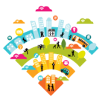  


# Access & Accessibility

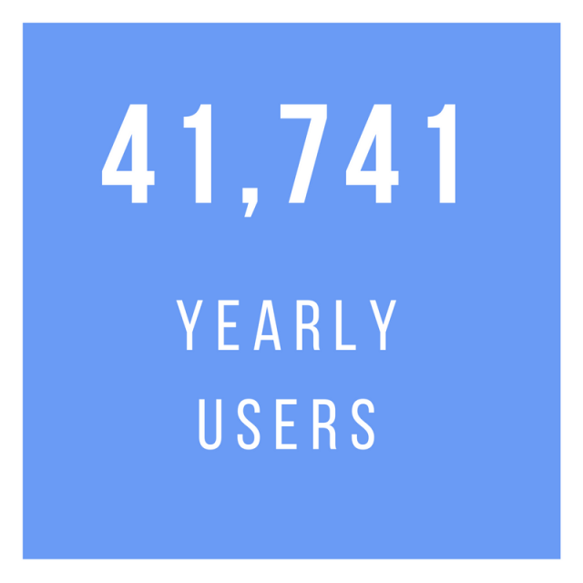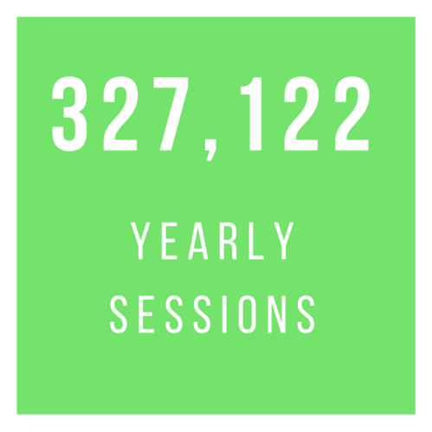 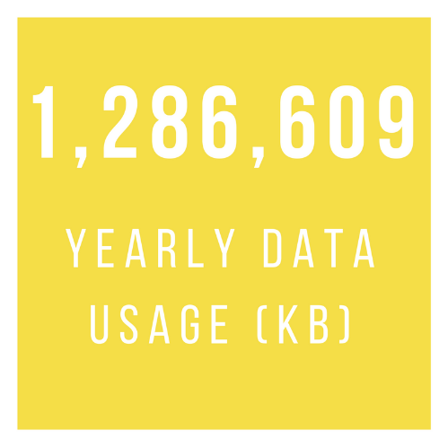

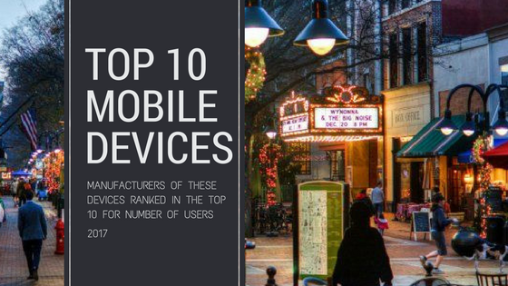

**Key Insights:**

* Apple dominates for the most users per device category (29.49% of all users).
* Samsung and LG additionally make up a large percentage of total device usage.

**What could do with this data?**

* Events to draw more Apple or tech users to the downtown mall may bring in greater volume for tech business and increase the number of wifi users.
* Consider opening a technology related store, such as an Apple store or device repair store, on the downtown mall.
* Alternatively, bring in these specific vendors during key technology related events such as the TomTom Festival.

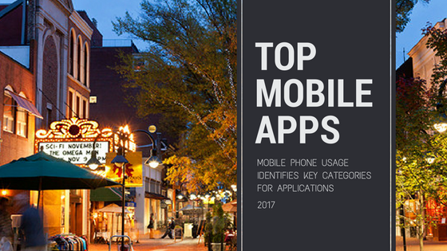

Key Insights:

* #1
* #2
* #3

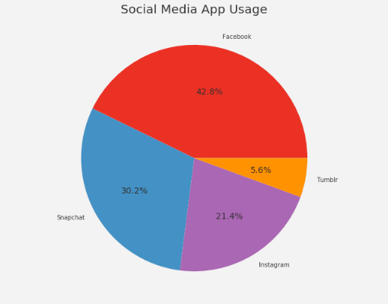 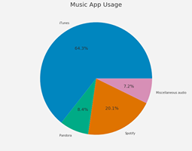 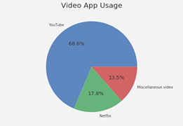

**Summary**

**text**



# Weather

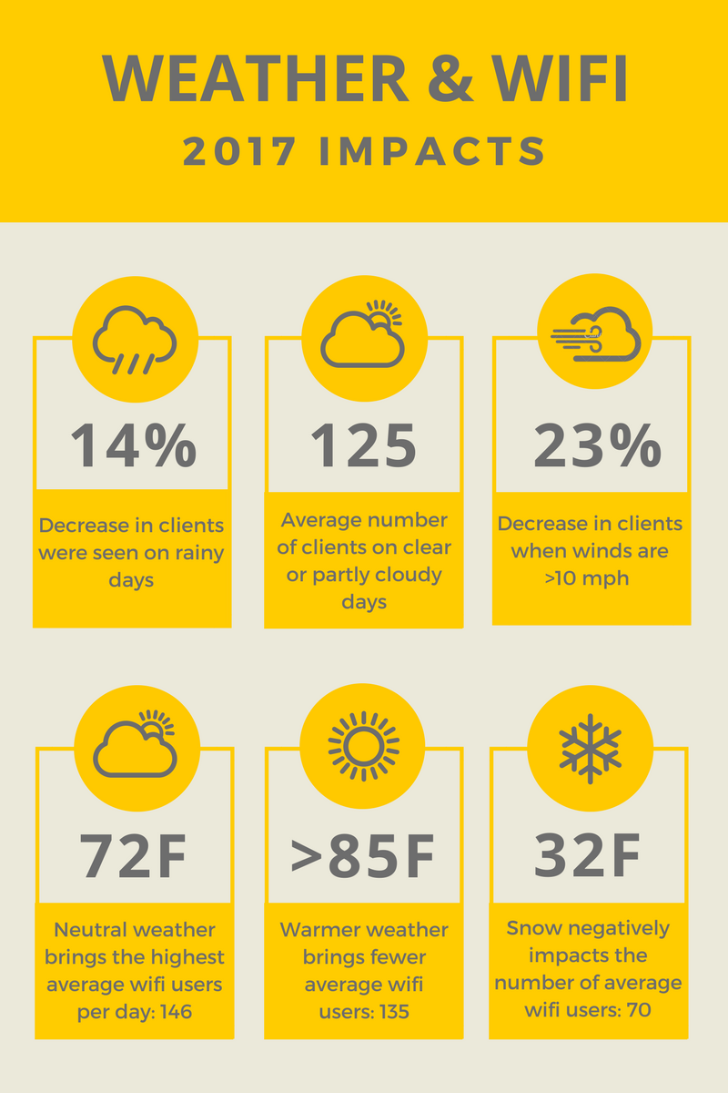

Key Insights:

* #1
* #2
* #3

**Percent decrease in wifi users:**

Clear days (125) vs Rainy Days (108)

**13.6% Decrease in Wifi Users**

Clear Days vs Cloudy Days both showed an equal average number of wifi users

**125**

Wind >10mph vs wind <10mph

92

119

22.6% decrease



# Events

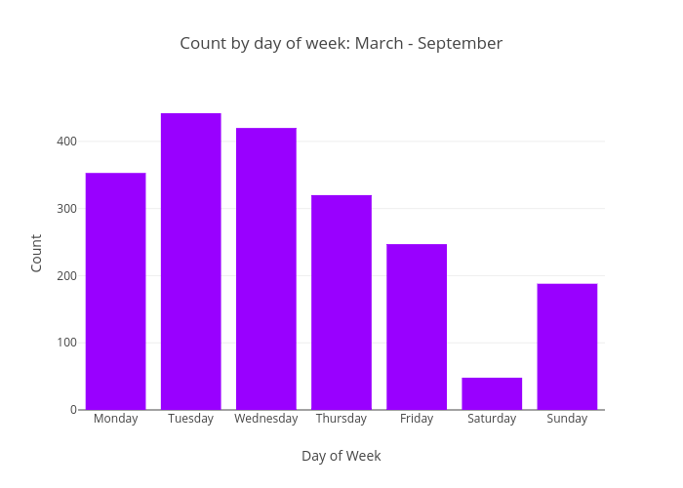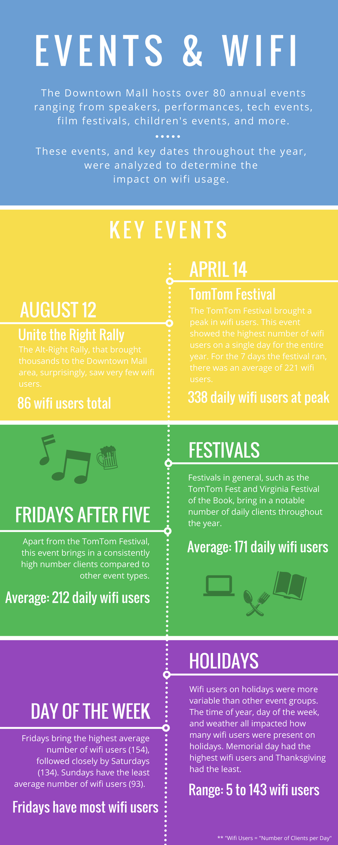

Key Insights:

* #1
* #2
* #3

Paragraph talking about this and practical applications or suggestions for coordinating future events, fundraisers.



**Summary**

**Paragraph that gets people connected to all of these graphs and data.**

**End with strong take away message**